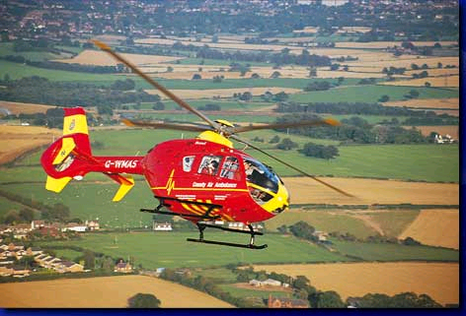
The Team Midland
Air Ambulance Fund Raiser

19th August 2007

Event HQ:-
Meriden Village Hall
Birmingham Rd
Meriden
Parking at HQ

First rider off at 8:01am

15.5mile Hilly Time Trial (course K26/15.5)

Free ride with a £5 donation to the County Air Ambulance service

Or bid for a team signed Aston Villa Team Shirt

Join with Team Midland to say thank you to the Air Ambulance Service

HQ open from 7.30 am. Signing-on at the start.

Course details (courtesy of midlanddc.org.uk):-
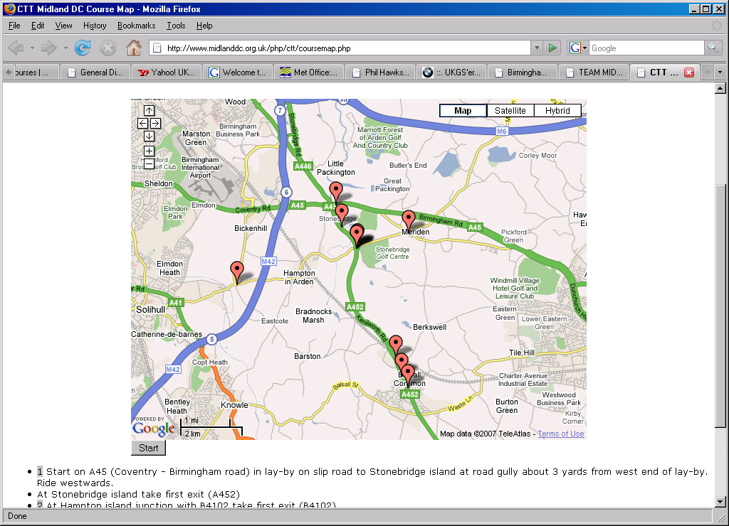
1 Start on A45 (Coventry - Birmingham road) in lay-by on slip road to Stonebridge island at road gully about 3 yards from west end of lay-by. Ride westwards. At Stonebridge island take first exit (A452)
2 At Hampton island junction with B4102 take first exit (B4102)
3 At Meriden island encircle island, taking fourth exit to retrace (B4102)
4 At Hampton island take second exit (A452)
5 At first island at Balsall Common (Shay house) take second exit (A452)
6 At next island Encircle island taking fourth exit and retrace (A452)
7 At Shay house island Take second exit (A452)
8 At Hampton island take first exit (B4102)
9 At Catherine de Barnes island junction with B4438 Encircle island taking fourth exit to retrace (B4102)
10 At Hampton island take first exit (A452)
11 Finish at start of first lay-by (adjacent 'P' sign), about 0.5 miles before Stonebridge island

